**NURSERY TWO CHILD CARE**

***Office Use Only***

Registration form Reg. Fee

Picture Sharing

Sunscreen

Deposit Agreement Deposit

Outside Food Policy

Website No to Allie

Immunizations & Form

Parent Manual signed

On Sandbox

Copy for Emergency Files

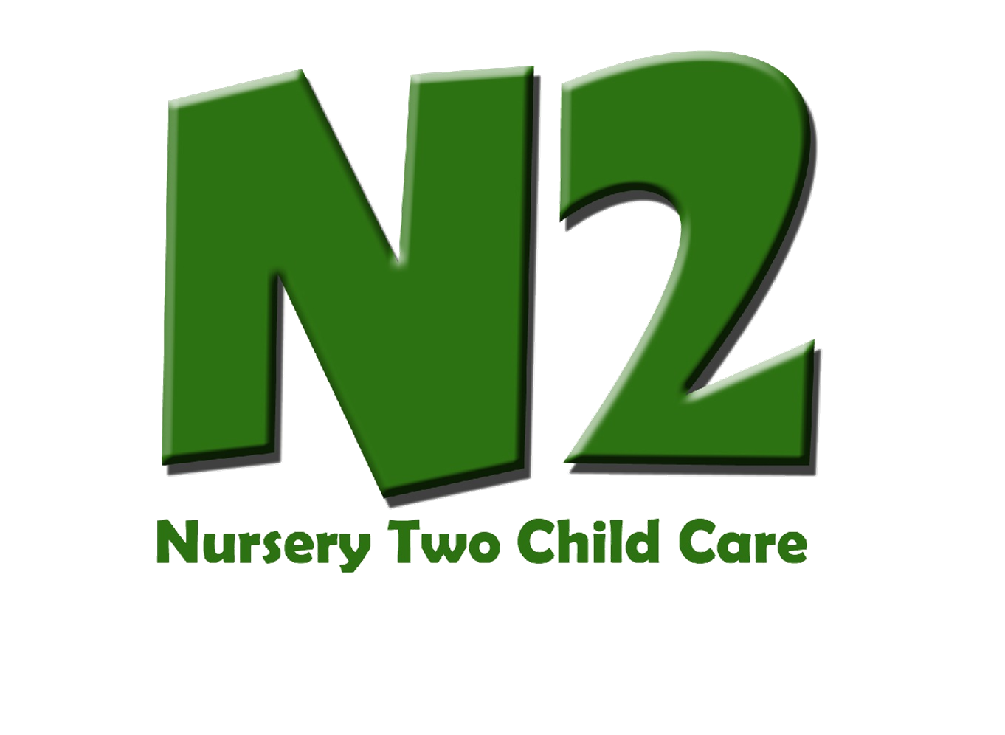

**REGISTRATION FORM**

**(705) 745-7553**

**FAX (705) 745-7571**

**nurserytwocc@gmail.com**

**Please circle which program your child will be attending:**

**N2 @ St. John • N2 @St. Alphonsus • N2 @ Otonabee Valley • N2 @ St. Joseph’s • N2 @ Keith Wightman**

**Requested Start Date: __________Actual Start Date: __________ Visit Dates: ________ Withdrawal Date: __________**

**Child’s Schedule: Please circle days and fill in needed times**

**Monday Tuesday Wednesday Thursday Friday**

**_______ _______ _________ ________ ______**

|  |
| --- |
| **Child’s Name:________________________ Date of Birth:_______________________________**  **Address:____________________________ City:____________________ Postal Code:______** |

|  |  |
| --- | --- |
| **Parent Name:_____________________________**  **Address:________________________________**  **City:___________________________________**  **Postal Code:______________________________**  **Work Address:____________________________**  **Name of Employer:________________________**  **Home Phone:______________ Cell:_______________**  **Work Phone: _________________Ext:_________**  **Email address: ____________________________** | **Parent Name:_____________________________**  **Address:________________________________**  **City:___________________________________**  **Postal Code:______________________________**  **Work Address:____________________________**  **Name of Employer:_______________________**  **Home Phone:_____________ Cell:_______________**  **Work Phone:_________________ Ext:_________**  **Email address: _____________________________** |

|  |
| --- |
| **Persons To Whom Child May Be Released (Other Than Parent)**  **Name: _________________________Phone #____________Cell #__________Work #_______________ Relation:__________**  **Name: _________________________Phone #____________Cell #__________Work #_______________ Relation:__________**  **Name: _________________________Phone #____________Cell #__________Work #_______________ Relation:__________**  ***Nursery Two will not release children to anyone under 18 years of age.*** |

|  |
| --- |
| **Emergency Contact Person (Other Than Parent)**  **Name:_________________________ Home Phone:_______________ Work Phone______________ Relation:_____________**  **Name:_________________________ Home Phone:_______________ Work Phone______________ Relation:_____________**  **Name:_________________________ Home Phone:_______________ Work Phone______________ Relation:_____________** |

|  |
| --- |
| **Doctor Name:__________________ Address: (Incl. Postal Code) _______________________Telephone:________________**  **Allergies:_________________________ Any Health Concerns:______________________________**  **Dietary Restrictions: _______________________________________________________________** |

|  |  |
| --- | --- |
| **Consent for:** | **Parent Signature:** |
| **The children will be going on impromptu walks and field trips within walking distance of the child care centre - please sign to indicate consent.** |  |
| **The news media and special guests visit the child care centre from time to time. We would appreciate your permission to allow your child to be photographed and/or filmed for internal use and for media or publicity – please sign to indicate consent.** |  |
| **In case of emergency I hereby give permission for my child to be taken to the hospital and/or give medical treatment if necessary – please sign to indicate consent.** |  |
| **In case of emergency evacuation I hereby give permission for my child to be transported via school bus/Nursery Two transportation vehicle to the designated evacuation site. (See Parent Manual for more details) – please sign to indicate consent.**  ***Please include custody forms if applicable.*** |  |

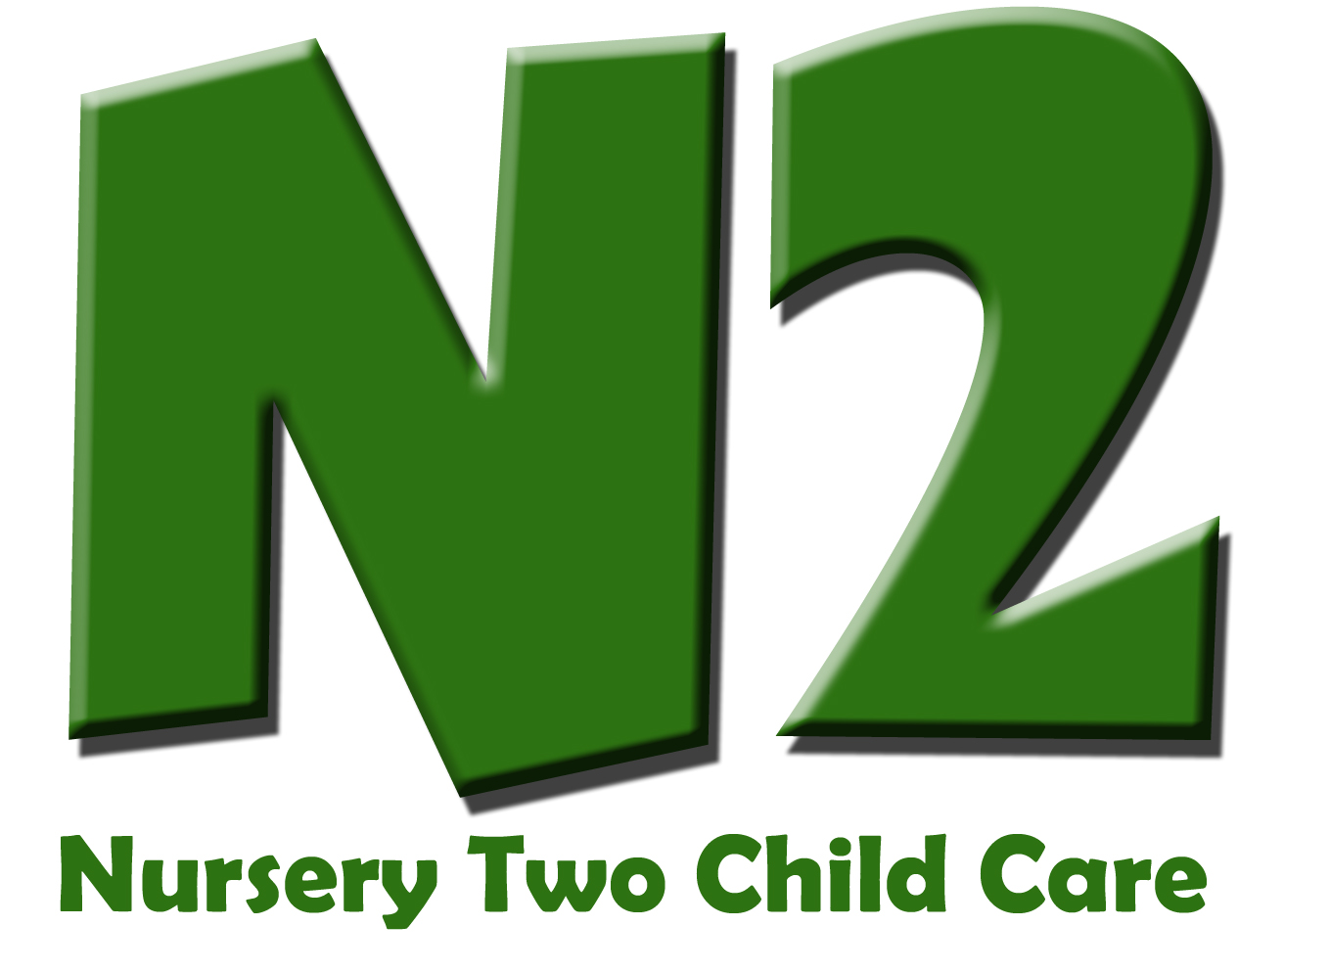

**Sharing Pictures Release Form**

Often our staff take pictures of the children throughout the day and have them on display for everyone to enjoy. From time to time staff would like to share these photos with you and your child in journals, picture sharing and on cards that can be taken home. Most photos have multiple children in them. In order for Nursery Two to send these photos home with your child(ren) and their friends, we need your permission.

Therefore:

I _________________________________________ give permission for Nursery Two Child Care to share my child ________________________’s photo with other children and families associated with their organization.

Parent Signature: _____________________________________________________________

Dated: ______________________________________________________________

**Permission to Administer**



**NON PRESCRIBED Medication**

**SUNSCREEN**

I hereby give my permission to the staff of Nursery Two Child Care to apply sunscreen to my child _____________________ according to the instructions printed on the ORIGINAL container.

From: (Child’s Start Date): ___________ - **onward \***

Name of Medication**: Nursery Two Sunscreen - Various Sunscreen brands, minimum 30 SPF**

Dosage: **apply to all exposed skin for any outdoor time**

Times to be given: **before outdoor time**

_____________________________

Signature of Parent/Guardian

* this form is effective until the above mentioned child’s *withdrawal date*.

*Office use only*

Nursery Two Child Care



Deposit Agreement

*The following is an agreement between yourself and Nursery Two Child Care, to hold a child care space for your child.* ***If you did not discuss holding a space when you signed your child(ren) up, please disregard this form.***

* All deposits for child care space will reflect two weeks of the care you require. Ex. If your child will be attending three days every week, you will be required to pay a deposit for six days of care, based on your child’s age.
* I (name) ____________________________________ have paid $__________ to Nursery Two Child Care as a deposit for my child (name) _____________________________.
* I understand that this will hold my child’s spot, and the deposit amount ($____________) will be taken off of my first child care bill. I understand this deposit is **non-refundable** if I do not end up taking the child care spot.
* I have also paid a non-refundable $40.00 Registration Fee. (Check box if reg. fee paid)
* **Start date:** _______________________________
* **Nursery Two location:** (please circle) St. John, St. Alphonsus, St. Joseph’s, Otonabee Valley, Keith Wightman

**Parent Signature:** ____________________________________________________

**Staff Signature:** ______________________________________________________

**Date:** ________________________________________________________



**No Outside Food Policy**

Due to various allergies and health concerns, children are not allowed to bring any outside food into our programs*. Children will not be allowed to have food that is not prepared at our facility while in any of our Programs. We provide children with snacks throughout the day as well as a full meal at lunch time, depending on the care your child has.

**\*Exceptions apply to infants enrolled in our Infant Program, in regards to bringing in breast milk, formula, etc.**

By signing below you are stating that you understand this policy, and will not bring outside food into any of Nursery Two Child Care’s programs.

Signature: _____________________________________________________

Date: ______________________________________



**Website Picture Release Form**

Often our staff take pictures of the children throughout the day and have them on display. Occassionally our website is updated with pictures from our programs. We need your permission to post pictures that have your child(ren) in them:

I ­____________________________________________ give permission for Nursery Two Child

Care to post my child ________________________________________’s picture on the Nursery Two website.

Parent Signature: _____________________________________________________________

Dated: _________________________________________

**\* names of children will not be put on our website**

*Please feel free to check out our website before*

*signing this form, to see how we display our pictures throughout:*

[*www.nurserytwochildcare.com*](http://www.nurserytwochildcare.com)

**Request for Immunization Information**



**For Children in Schools or Day Nurseries**

**Confidential when Completed**

Immunization is the best way to protect your child from vaccine preventable diseases.

**Please complete this form and ATTACH A COPY OF THE CHILD’S IMMUNIZATION RECORD.**

Under the Immunization of School Pupils Act and the Child Care and Early Years Act, the Health Unit ensures that all children in the Peterborough County and City have adequate immunization against tetanus, diphtheria, polio, measles, mumps, rubella, meningococcal disease, pertussis (whooping cough), and varicella (chicken pox). A valid exemption is needed for those who choose not to immunize. (NOTE: For children in Day Nurseries, you may have to provide an additional copy of your immunization information directly to the Day Nursery.) **Please ensure that the name and birthdate of the child is also included on the immunization record.**

It is up to the parent/guardian to provide proof of the child’s immunization to the Health Unit, as the Acts do not require family doctors or nurse practitioners to provide this information. For more information or if you have any questions, please call a Vaccine Preventable Disease Program Nurse at (705)743-1000.

This information is collected and used by Health Unit programs under the authority of Sections 2 and 5 of the Health Protection and Promotion Act and Ontario Reg. 585/94 under the Health Cards and Numbers Control Act 1991, and Section 11 under the Immunization of School Pupils Act, R.S.O. 1990 and the Child Care and Early Years Act, S.O. 2014. For further details regarding the collection, contact the Health Unit at (705)743-1000.

|  |  |
| --- | --- |
| Child’s Last Name |  |
| Child’s First Name |  |
| Other First Names Used |  |
| Other Last Names Used |  |
| Birthdate (YYYY/MM/DD) |  |
| Gender |  |
| Name of School or Day Nursery |  |
| Ontario Health Card Number |  |
| Address |  |
| City |  |
| Postal Code |  |
| Contact--Phone Number(s) |  |
| Contact--Email |  |
| Parent/Guardian Full Name |  |
| Parent/Guardian Signature |  |
| Date (YYYY/MM/DD) |  |
| Please check one of the following below:  ____ Vaccination record is attached  ____ I will call my health care provider obtain this information and send it to the Health Unit  ____ No vaccine record attached to this form→ Reason: | |